**Exploring Pizza Sales Revenue Trends, Ordering Patterns, Category Performance, and Visual Insights with SQL and Power BI**

**PIZZA**

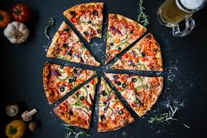

**INTRODUCTION**

This project presents an in-depth analysis of pizza sales data using SQL in a MySQL environment. The goal of the analysis is to uncover key insights into sales performance, customer ordering behavior, and product popularity. By leveraging SQL queries, we extract critical business metrics such as total revenue, average order value, and total pizzas sold. Additionally, the analysis includes time-based trends, like hourly and weekly sales patterns, which provide valuable insights into peak sales periods.

The project further categorizes sales data by pizza category and size to analyze their contributions to total revenue. This includes calculating the percentage of sales generated by each pizza category and size, giving the business a clearer picture of customer preferences. Moreover, we identify the top-performing pizzas in terms of revenue, quantity sold, and order frequency, enabling targeted marketing and inventory management strategies.

Using MySQL as the database management system, this project showcases the power of SQL for performing complex aggregations, grouping, and ordering functions to derive actionable insights from raw sales data. The findings can guide data-driven decisions for pricing, product development, and promotional strategies to drive future growth and customer satisfaction.

**Dataset Overview**

The dataset used in this project contains 48,620 records detailing pizza sales transactions. Each entry represents an individual pizza order and includes the following columns:

* pizza_id: Unique identifier for each pizza item.
* order_id: Identifier for each order, allowing aggregation of items per order.
* pizza_name_id: An identifier for the pizza type and size.
* quantity: Number of pizzas of a particular type in each order.
* order_date and order_time: Date and time when the order was placed, useful for time-based analysis.
* unit_price and total_price: Price per unit of pizza and the total price based on quantity.
* pizza_size: Size of the pizza (e.g., Small, Medium, Large).
* pizza_category: Category such as Classic, Veggie, or Supreme, indicating the pizza type.
* pizza_ingredients: Ingredients used in each pizza, providing insights into customer preferences.
* pizza_name: Full name of the pizza, like "The Hawaiian Pizza."

This data structure is ideal for analyzing sales trends, popular pizza categories, and customer preferences. The data is also well-suited for visualizing sales patterns in Power BI, enabling meaningful insights into revenue, product popularity, and order timing.

**SQL QUERIES**

**1.Total Revenue**

select round(sum(total_price),2) as total_revenue from pizza



**2. Average order Value**

select round(sum(pizza.total_price)/count(distinct(pizza.order_id)),2) as average_value from pizza



**3. Total Pizza Sold**

select sum(pizza.quantity) as total_pizza_sold from pizza



**4. Total order**

select count(distinct(pizza.order_id)) as Total_order from pizza



**5. Average pizza per order**

select round(sum(pizza.quantity)/ count(distinct(pizza.order_id)),0) as Avg_pizza_per_order from pizza



**6. Hourly trend for total pizzas sold**

select

date(order_time) as order_date,

hour(order_time) as order_hour,

sum(quantity) as total_quantity

from

pizza

group by date(order_time), hour(order_time)

order by order_date, order_hour;

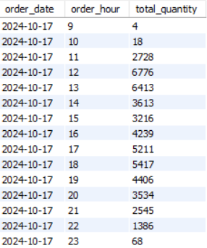

**7. Weekly Trend for total orders**

select week(order_date, 1) as week_number,

year(order_date) as order_year,

count(distinct order_id) AS total_orders

from pizza

group by week(order_date, 1), year(order_date)

order by week_number, order_year;

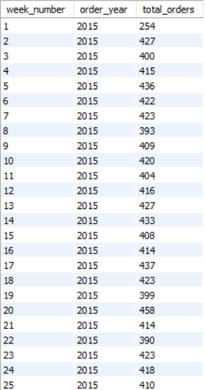

**8. Percentage of sales by pizza category**

SELECT

pizza.pizza_category,

ROUND(SUM(total_price) * 100 / (SELECT SUM(total_price) FROM pizza WHERE MONTH(order_date) = 1), 2) AS percentage_of_sales

FROM

pizza

WHERE

MONTH(order_date) = 1

GROUP BY

pizza.pizza_category;

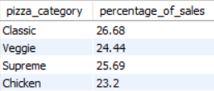

**9. Percentage of sales by pizza size**

SELECT

pizza.pizza_size,

ROUND(SUM(total_price) * 100 / (SELECT SUM(total_price) FROM pizza WHERE QUARTER(order_date) = 1), 2) AS percentage_of_sales

FROM

pizza

WHERE

QUARTER(order_date) = 1

GROUP BY

pizza.pizza_size

ORDER BY

percentage_of_sales DESC;

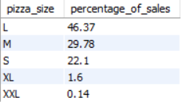

**10. Top 5 best sellers by revenue, total quantity and total orders**

SELECT

pizza.pizza_name,

SUM(pizza.total_price) AS revenue,

SUM(pizza.quantity) AS total_quantity,

SUM(pizza.order_id) AS total_orders

FROM

pizza

GROUP BY pizza.pizza_name

ORDER BY revenue DESC

LIMIT 5

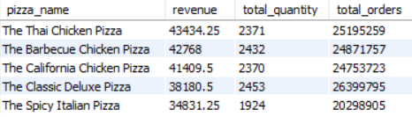

**DASHBOARD**

The dashboard for this project is created in Power BI to transform raw sales data into interactive visuals and reports that provide a clear picture of pizza sales trends, order patterns, and category performance. The dashboard includes key metrics such as total revenue, average order value, most popular pizza categories, hourly and weekly sales trends, and a breakdown of sales by pizza size and category. These visual elements allow stakeholders to easily explore data and identify actionable insights.

